ELEC 152
MODULE 5: MESH & NODAL ANALYSIS; SUPERPOSITON THEOREM
M5A2
Problem 1. Using superposition, find the current (value and direction) in each resistor.
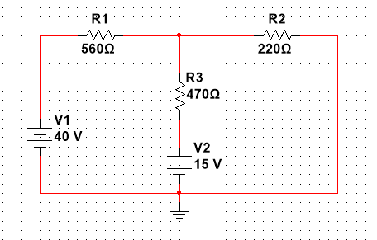

Problem 2. Use superposition to calculate the current (value and direction) through each resistor.
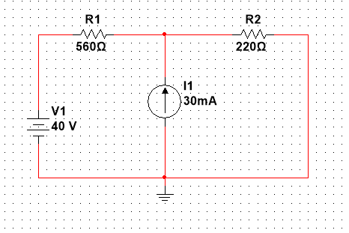
Problem 3. Using superposition calculate the power supplied or absorbed by each source.
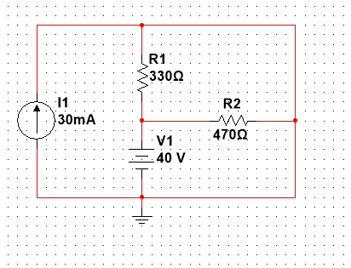

Problem 4. Calculate the voltage across R1 using superposition:
